Jan KOWALSKI¹, Stanisław NOWAK²
Zachodniopomorski Uniwersytet Technologiczny w Szczecinie, Katedra Maszyn Elektrycznych (1)
Uniwersytet Zielonogórski, Instytut Automatyki, Elektroniki i Elektrotechniki (2)

Maszyna elektryczna z magnesami trwałymi

Streszczenie. Lorem ipsum Lorem ipsum Lorem ipsum Lorem ipsum Lorem ipsum Lorem ipsum Lorem ipsum Lorem ipsum Lorem ipsum Lorem ipsum Lorem ipsum Lorem ipsum Lorem ipsum Lorem ipsum Lorem ipsum Lorem ipsum Lorem ipsum Lorem ipsum Lorem ipsum Lorem ipsum Lorem ipsum Lorem ipsum Lorem ipsum Lorem ipsum.

Słowa kluczowe: lorem ipsum, lorem ipsum, lorem ipsum, lorem ipsum, lorem ipsum.

Konstrukcja maszyny
Lorem ipsum, lorem ipsum, lorem ipsum, lorem ipsum, lorem ipsum, lorem ipsum, lorem ipsum, lorem ipsum, lorem ipsum, lorem ipsum, lorem ipsum, lorem ipsum, lorem ipsum, lorem ipsum, lorem ipsum, lorem ipsum, lorem ipsum, lorem ipsum, Fig. 1. Lorem ipsum, lorem ipsum, lorem ipsum, lorem ipsum, lorem ipsum, lorem ipsum, lorem ipsum, lorem ipsum, lorem ipsum, lorem ipsum, lorem ipsum, lorem ipsum, lorem ipsum.
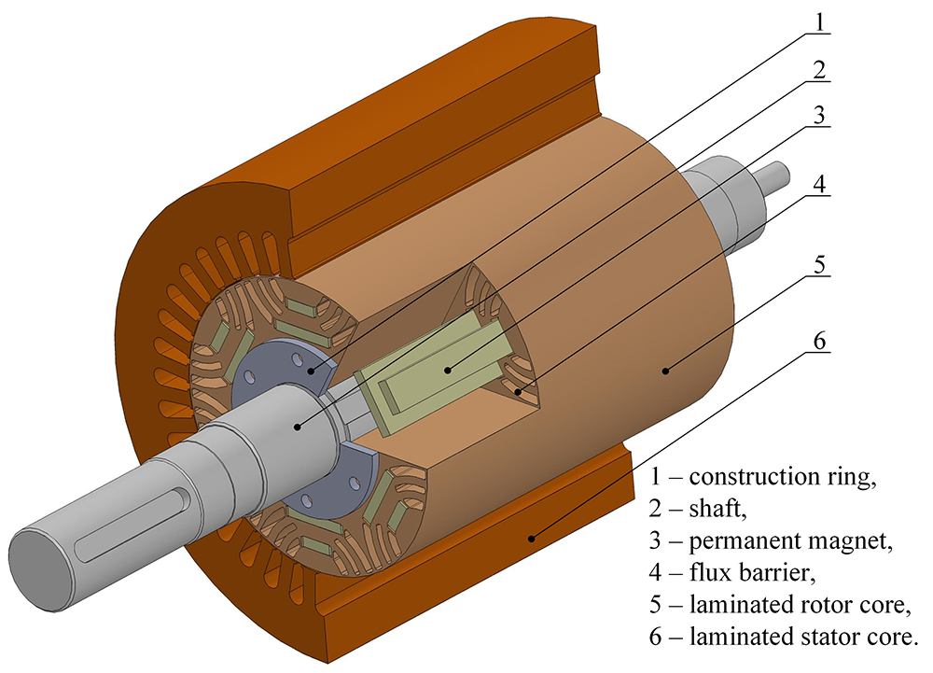

Rys.1. Proponowana struktura maszyny.

Badania maszyny
Lorem ipsum, lorem ipsum, lorem ipsum, lorem ipsum, lorem ipsum, lorem ipsum, lorem ipsum, lorem ipsum, lorem ipsum, lorem ipsum, lorem ipsum, lorem ipsum, lorem ipsum, lorem ipsum, lorem ipsum, lorem ipsum, lorem ipsum, lorem ipsum, lorem ipsum, lorem ipsum, lorem ipsum, Fig. 2.

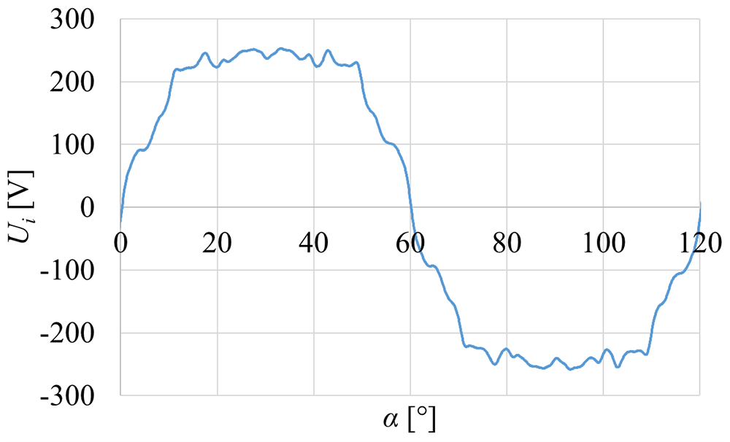
Rys.2. Wyniki badań maszyny.

Wnioski
Lorem ipsum, lorem ipsum, lorem ipsum, lorem ipsum, lorem ipsum, lorem ipsum, lorem ipsum, lorem ipsum, lorem ipsum, lorem ipsum, lorem ipsum, lorem ipsum, lorem ipsum, lorem ipsum, lorem ipsum, lorem ipsum, lorem ipsum, lorem ipsum, lorem ipsum, lorem ipsum, lorem ipsum.

Literatura
- Youguang Guo, Student Member, IEEE, Jian Guo Zhu, Senior Member, IEEE, Jin Jiang Zhong, and Wei Wu, Core Losses in Claw Pole Permanent Magnet Machines With Soft Magnetic Composite Stators, IEEE Transactions on Magnetics, vol. 39, no. 5, 2003, pp. 3199-3201.
- Y. Burkhardt, K. Schleicher, M. Klöpzig, A novel hybrid excited synchronous machine for (H)EV applications, IEEE Xplore, 2014.

Autorzy: prof. dr hab. inż. Jan Kowalski, West Pomeranian University of Technology, Szczecin, Sikorskiego 37, 70-313 Szczecin, e-mail: jan.kowalski@zut.edu.pl; prof. dr hab. inż. Stanisław Nowak, Uniwersity of Zielona Góra, Instytut Automatyki, Elektroniki i Elektrotechniki, Podgórna 50, 65-246 Zielona Góra, e-mail: stanislaw.nowak@uz.zgora.pl.

